NATURAL SELECTION **ANSWERS** 10 AUGUST 2024

**Paper 2 – November 2014**

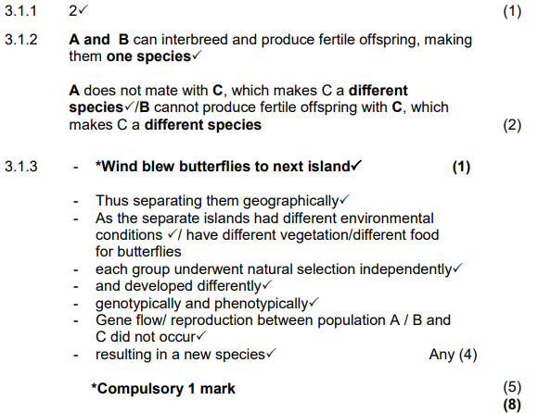

**Paper 2 – November 2015**

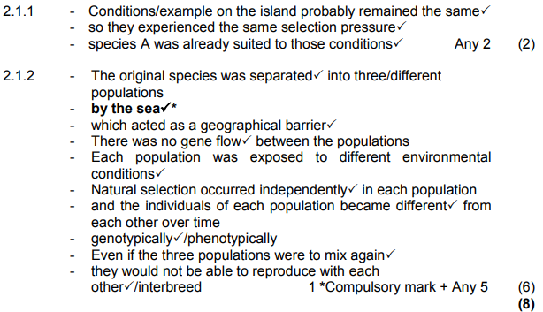

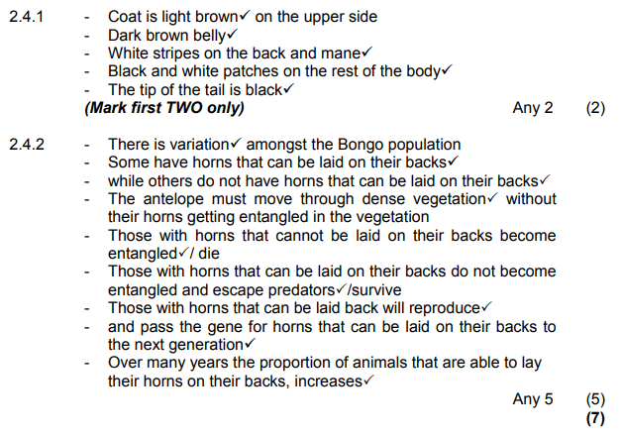

**Paper 2 – November 2016**

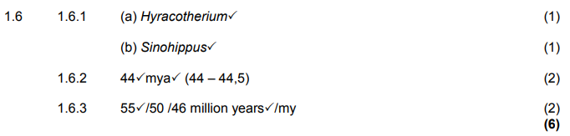

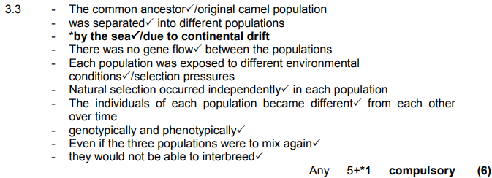

**P2 – November 2017**





